WEEK 5 WORKBOOK: ARCHITECTURAL DESIGN
GROUP: GROUP 2
PROJECT: HEALTHBRIDGE
INSTITUITION: MBARARA UNIVERSITY OF SCIENCE AND TECHNOLOGY
GROUP MEMBERS
NAME | REGISTRATION NUMBER
Tumukunde Isaac | 2024/BCS/162/PS
Aryamanya Lucky | 2024/BCS/045/PS
Nambatya Bladina Doreen | 2024/BCS/128/PS
Nanjuki Daphine | 2024/BCS/129/PS
Kusingura Jachin | 2024/BCS/091/PS
Arinda Leticia | 2024/BCS/043/PS

SECTION 2: CONCEPT BUILDING
ACTIVITY2.1: UNDERSTANDING ARCHITECTURE
TASK 1:
Software architecture:
Software architecture is the high-level structure of a software system or the set of principal components, their relationships, and the governing design principles that guide the system's development and evolution. It is the blueprint that determines how the system is organized and how its parts work together to fulfil the system's goals.

TASK 2:
Architectural Design:
Architectural design is the process of identifying the major structural components of a system, defining how they interact, and making key decisions about the overall organisation before any code is written. It translates requirements into a workable technical structure that developers can follow.

Why is architecture a bridge between requirements and design?
Requirements describe what the system must do; detailed design describes how each small piece works. Architecture sits between them and it decides which components exist and how they communicate, thereby converting high-level stakeholder needs into a concrete structure that development teams can implement piece by piece.

Activity 2.2: Architecture in Practice

Five major components of the system

Component 1. User Management

Component 2. Course Content Module

Component 3. Assessment Engine

Component 4. Notification Service

Component 5.Database

Interactions:
User management Authenticates students and lecturers and passes identity tokens to all other components
Course Content Module Sends/receives course materials from Storage and serves content to the UI layer
Assessment Engine Receives quiz attempts from the user interface and writes grades to the database
Notification Service Listens for events like new assignment, grade posted and pushes alerts to users
Database stores all user data, course files, and grades and queried by all other components

SECTION 3: Architectural Design Decisions

Activity 3.1: Key Decisions for HealthBridge
Decision Area | Your choice | reason
System Type | Web-based Information System | Accessible from any device with a browser  No app installation needed Critical for low-resource users
Architecture Style | MVC (Model-View-Controller) | Clear separation of data, logic, and user interface makes the system easy to maintain and update by different team members
Deployment | Cloud-hosted for example Google Cloud | Supports horizontal scaling as user base grows  Eliminates hardware dependency at the NGO
Data Storage | Relational Database Management System i.e. MySQL /PostgreSQL and Redis cache | Structured data (clinics, medicines, locations) fits the relational model  Redis speeds up frequent map queries
Security Approach | bcrypt password hashing  server-side input validation  HTTPS, JWT auth, input sanitization, no logging of sensitive searches | Protects all admin session data in transit  prevents SQL Injection  bcrypt with salt protects admin credentials stored in the database  Health searches are sensitive — GDPR/HIPAA principles must be respected to protect user privacy

Activity 3.2 Non-functional Requirements Mapping
Quality Attribute | How the HealthBridge Architecture supports it
Performance | Redis caching for frequent clinic queries  Optimized SQL indexes on location and service-type fields  CDN for static assets. Target: search results delivered in under 2 seconds
Security | All traffic over HTTPS/TLS;  parameterized SQL queries prevent injection; bcrypt password hashing;  no sensitive search terms (e.g. HIV clinic) are written to server logs
Availability | Cloud deployment with auto-restart policies  Daily database backups  Admin panel so non-technical staff can correct data without developer involvement.
Maintainability | MVC layers separate concerns cleanly  admin CRUD(Create, Read, Update, Delete) interface means clinic staff can update hours without touching code  clear folder structure for developer onboarding

SECTION 4 ARCHITECTURAL VIEWS (4+1 MODEL)
Activity 4.1: Understanding views
view | Description
Logical View | Describes the system's functional structure, the key components, their responsibilities, and their relationships. Describes what does the system does.
Process View | Describes the system's dynamic runtime behaviour  how processes, threads, and components communicate during execution. That is to say how does the system behave while running?
Development View | Describes the system from the programmer's perspective  How the codebase is organised into modules, packages, and layers; how is the code structured?
Physical View | Describes the mapping of software onto physical hardware servers, devices, cloud infrastructure, and network topology; where does the system run?
+1 (Use Cases) | The central view that ties all others together key scenarios (use cases) that the architecture must support. They drive and validate the other four views.

Activity 4.2 Apply to HealthBridge
Logical View
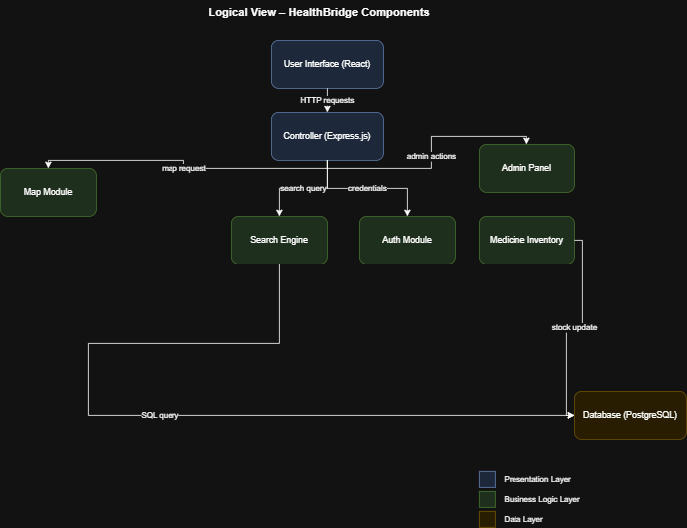

Process View

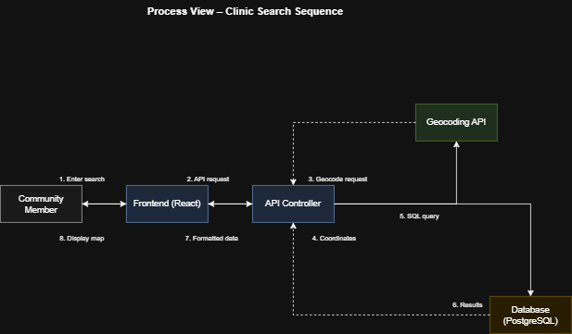

Development View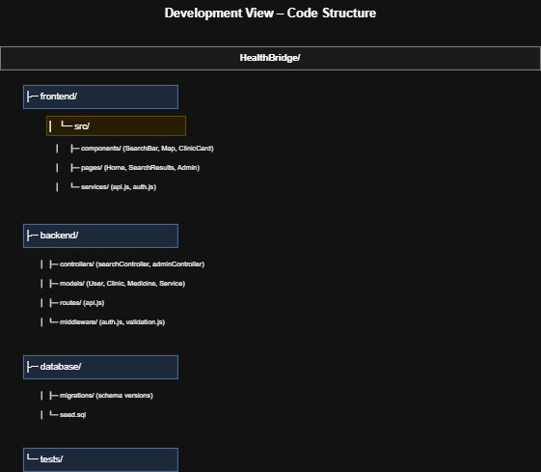

Physical view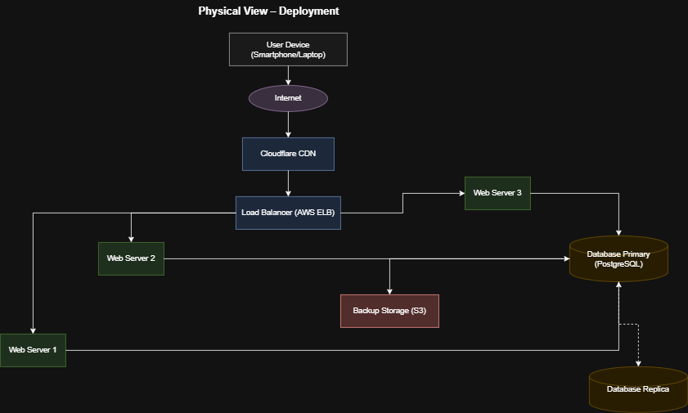

Use Case View
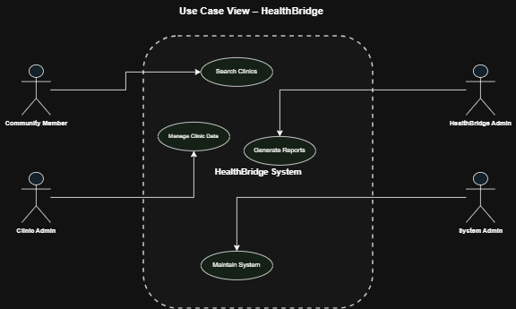

SECTION 5: ARCHITECTURE PATTERNS

Activity 5.1: pattern matching

System type | Suggested pattern
Web Application | MVC (Model-View-Controller)
Banking System | Layered Architecture
Compiler | Pipe and Filter
Data Processing System | Repository

Activity 5.2 Apply Patterns to Your Project

Choose ONE pattern and justify:
Chosen pattern-option A: MVC (MODEL-VIEW-CONTROLLER)
We chose MVC (Model-View-Controller) because HealthBridge is a data-driven web application where separating the presentation from the business logic and the database is essential. Different team members can work on each layer simultaneously without conflict.
MODEL: PostgreSQL/MYSQL schemas managed via Sequelize ORM

VIEW: React.js / HTML+CSS pages rendered in the browser

CONTROLLER: Node.js/Express route handlers

OPTIONB: LAYERED ARCHITECTURE

Draw layers:
Presentation layers


Application layer

Data layer

Complete Layered Architecture for HealthBridge
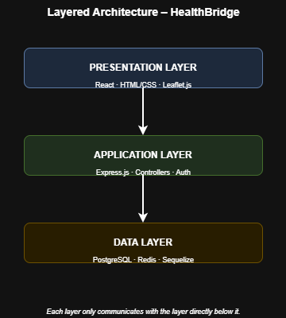

OPTION C: CLIENT-SERVER
Identify:
Clients: Community Member, Clinic Administrator, HealthBridge Administrator
Servers: Web Server, Application Server, Database Server, Caching Server, Backup / Storage

SECTION 6: APPLICATION ARCHITECTURES
Activity 6.1: Identify Your System Type
Ticked: Data Processing System
Justification: HealthBridge's core function is to collect, store, and process data about clinics and medicines so that community members can query and retrieve it meaningfully making it fundamentally a Data Processing System.

Activity 6.2: Real-World Analysis
Organization: Ruharo Mission Hospital & Community Health NGO, Mbarara, Uganda
System Type: Data Processing System
Architecture Currently Applied: No formal software architecture: decentralized, file-based manual process with no backup or version control Challenges Observed
Challenges observed:
- Clinic hours change frequently without notification
- Low-bandwidth users need lightweight pages optimized for slow mobile connections.
- Privacy of health searches; sensitive queries (HIV, mental health) must never be logged
- No central authority to verify clinic listing accuracy whereby it relies on community

SECTION 7: GROUP PROJECT APPLICATION
FINAL TASK: Design Your System Architecture
7.1. System Overview
System name: HealthBridge System

Purpose : A centralised, web-based Community Health Resource Locator that provides community members in underserved areas with accurate, real-time information about nearby health clinics, available medicines, and health education resources. Replacing the slow, unreliable manual process at Ruharo Mission Hospital
Users: Community Members, Clinic Administrators, HealthBridge Administrators, System Administrator
7.2. Architectural Design
Chosen architecture pattern: MVC (Model-View-Controller)
Justification:
because HealthBridge is a data-driven web application where separating the presentation from the business logic and the database is essential. Different team members can work on each layer simultaneously without conflict

7.3. Diagrams
Context Diagram
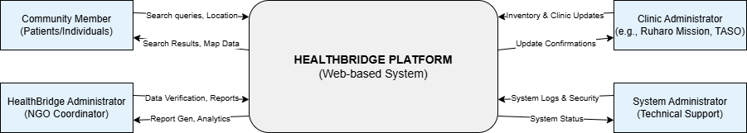
High-level Architecture Diagram
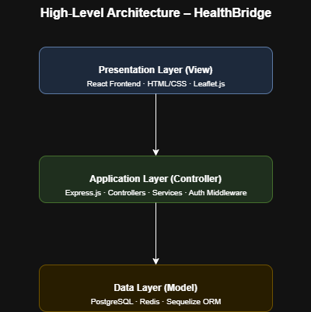
4+1 Views (at least 2 views)
Physical view
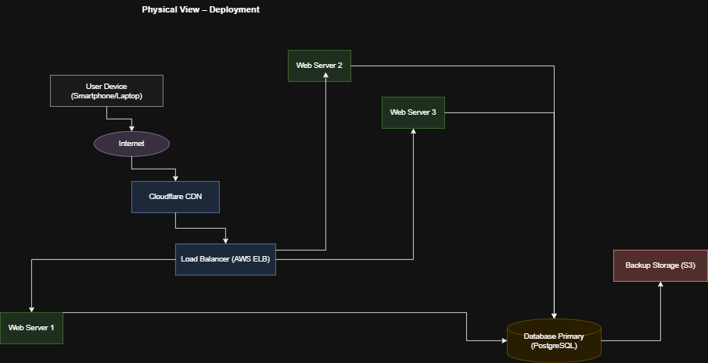
Development View


7.4. Component Description
component | Role in HealthBridge
Search engine | Takes user input (location, service type), queries the database with geo-filtering, returns a ranked list of matching health facilities
Map Module | Integrates OpenStreetMap/Leaflet.js to display clinic location pins on an interactive map  shows walking/driving directions
Auth Module | Handles user registration, login, JWT session tokens, and role-based access control (community user vs. admin/clinic staff)
Admin Panel | Allows non-technical clinic staff to add, edit, and delete clinic hours, contact info, and services via a simple form-based user interface and no coding required
Notification service | Sends SMS/email alerts via Africa's Talking when clinic hours change or a user's saved facility updates its information
Medicine availability | Lists medicines by clinic  admin staff mark current availability  community users can filter search results by medicine name
Review system | Community members rate clinics (1–5 stars) and flag outdated information, helping to crowdsource data accuracy verification
PostgreSQL/MYSQL database | Persists all structured data: clinics, medicines, users, reviews, health programs, and appointment records
Redis cache | Stores results of the 50 most frequent search queries to reduce database load and improve response speed for common lookups

5. Technology Stack
layer | technology
Frontend | React.js · Tailwind CSS · Leaflet.js · Axios
Backend | Node.js · Express.js · Sequelize ORM · JWT
Database | PostgreSQL /MYSQL and Redis

7.6. Non-functional Requirements
How the system ensures:
Security
All traffic encrypted over HTTPS/TLS. Passwords hashed with bcrypt. Parameterized SQL queries prevent injection attacks. Sensitive search terms (HIV, mental health, abortion clinic) are never written to any server logs. JWT tokens expire after 24 hours and must be refreshed.

Performance
Redis caches the top 50 most frequent clinic search queries. Database indexes on location (latitude/longitude) and service-type columns. Cloudflare CDN serves all static React assets. Target: search results returned in under 2 seconds on a 3G connection.

Scalability
Stateless REST API design allows horizontal scaling (add more app server instances under a load balancer without any code changes). Redis reduces database pressure by 60–80% for common queries. Architecture designed to scale from city-wide to national coverage without restructuring.

SECTION 8: REFLECTION
Individual Reflection
8.1.What was the most challenging concept?
The 4+1 Architectural Views model was the most challenging concept to grasp. Understanding that the same system must be described from four entirely distinct perspectives logical, process, development, and physical and that each view serves a different stakeholder audience (developers, testers, network engineers, end-users) required a significant shift in thinking
8.2.What architectural decision did your group struggle with?
The 4+1 Architectural Views model was the most challenging concept. It requires thinking about the same HealthBridge system from four completely different perspectives simultaneously, logical structure, runtime behavior, code organization, and physical deployment. Understanding that these are not separate systems, but different lenses on the same system, required careful thinking. For example, the Clinic Module appears in the Logical View as a component, in the Process View as a series of CRUD API calls, in the Development View as a Django app directory, and in the Physical View as part of the application server VM.
How would you improve your design?
- Offline-first PWA (Progressive Web App): Add service workers so the app works in low-connectivity areas critical in rural Uganda where network coverage is unreliable. A cached version of nearby clinics would allow users to access data even without internet.
- SMS-only interface: Build an SMS bot using Africa's Talking so users without smartphones can text a keyword to receive the nearest clinic by SMS serving the most vulnerable users who only have feature phones.
- Appointment booking module: Allow community members to book appointments directly through HealthBridge, reducing clinic queue times and enabling better resource planning for health facilities.

BONUS TASK (Advanced Students)
Compare TWO architectures:
Layered vs Client-Server
With Layered architecture System is divided into horizontal layers (Presentation, Application, Data). Each layer only communicates with the layer directly below it while client-server architecture Processing is split between a centralised server and multiple clients. The server holds data and logic; clients request services over a network.
LAYERED ARCHITECTURE
ADVANTAGES
- Clear separation of concerns
- Each layer developed and tested independently
- Easy to enforce security rules between layers; good for complex business logic.
DISADVANTAGES
- Performance overhead i.e. every request must pass through all layers even when unnecessary
- Strict layering can slow development.
Best Use Case
Enterprise systems with strict business rule enforcement like banking, hospital information systems.
CLIENT-SERVER ARCHITECTURE
ADVANTAGES
- Centralises data ensuring consistency
- Enables many diverse clients to access the same backend
- Easy to update server without touching clients.
DISADVANTAGES:
- Server becomes a single point of failure if not replicated
- Network latency can affect user experience
- Requires internet connectivity.
Best Use Case
Web and mobile applications serving multiple client types that use different devices.

MVC vs Repository
MVC Separates the application into Model (data + rules), View , and Controller (logic handling requests) yet Repository pattern Abstracts all data access behind a repository interface; the application code never directly queries the database it calls the repository.
MVC
ADVANTAGES:
- Cleanly separates UI, logic, and data
- natively supported by Django, Laravel, Rails
- Ideal for web apps
- Rapid development.
DISAVANTAGES:
- Can become unwieldy for complex domains, the Controller can become bloated as the application grows.
- Best Use Case: Web applications with a clear UI layer where Django's built-in ORM, auth, and REST framework map directly onto MVC.

REPOSITORY:
ADVANTAGES:
- Makes it very easy to swap databases without changing business logic
- Highly testable
DISADVANTAGES:
- Adds an extra layer of abstraction which can be over-engineering for small projects in its initial time release.
- Best Use Case
- Domain-driven enterprise systems where the data source may change, or where rigorous unit testing of data logic in isolation is critical.

